UI

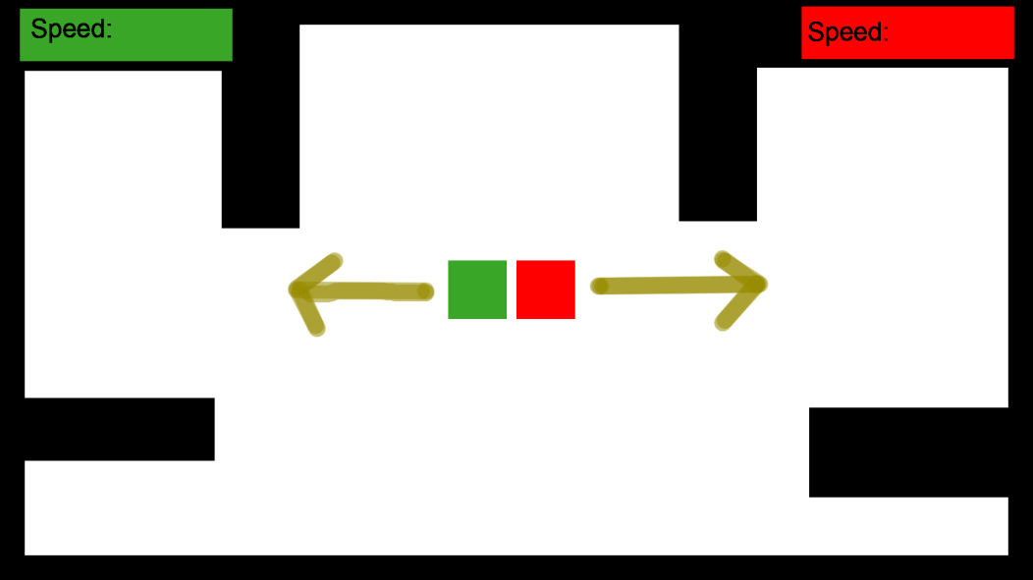

The User Interface needs to be simple and intuative to players. For this reason the above image is not the final colour scheme or art assets for the UI but a representation of what the will be.

Whatever colours will identify the player pieces will also identify the speed counters. Players will be told at the beginning that the first player to stop moving loses so they should link this win condition to the displayed statistic of speed quite easily.

Players should find the scores being at the top of the sceen very familiar, also the scores are displayed on the side of the screen that their coresponding player piece is first located on to further help identify to players which score belongs to them.

The UI has been left very minimal at the moment and unless we add any mechanics that force the player to be aware of other pieces of information on the screen it should be left that way.

It should also be noted that where ever the scores will be located should be blocked off to the player so that they dont find their view obstructed.